# PREPARATION AND MAINTENANCE OF ZOHO BOOKS

# HEAITH HUB MEDICAL CLINIC

**INTRODUCTION:**

# Welcome to Health Hub Medical Clinic! We understand that running a healthcare facility involves not just medical expertise but also efficient financial management. That's why we have chosen Zoho Books as our financial management software to streamline our clinic's accounting and bookkeeping processes. In this overview, we'll discuss how Zoho Books can help us manage our finances, so we can focus on providing quality healthcare to our patients.

**Overview of Zoho Books for Health Hub Medical Clinic:**

***Financial Tracking:***

Zoho Books allows us to maintain accurate and up-to-date financial records. We can easily track income, expenses, and profits related to our clinic's operations. This means we always have a clear picture of our clinic's financial health.

***Invoicing:***

We can create and send professional invoices to our patients and insurance providers directly through Zoho Books. This helps us get paid faster and ensures that our billing processes are organized and efficient.

***Top of Form***

***Expense Management:***

Managing expenses is crucial for any business, and a medical clinic is no exception. Zoho Books enables us to record and categorize expenses, ensuring that we have full control over our spending.

***Tax Compliance:***

In the healthcare industry, dealing with various tax rates and regulations can be complex. Zoho Books supports multiple tax rates and helps us calculate and manage taxes related to patient services and purchases.

***Financial Reporting:***

Zoho Books offers a variety of financial reports, including profit and loss statements, balance sheets, and cash flow reports. These reports provide valuable insights into our clinic's financial performance, helping us make informed decisions.

***Integration:***

Zoho Books integrates seamlessly with other Zoho products and third-party applications. This ensures that we can connect our financial data with other systems in use at our clinic, such as our Electronic Health Record (EHR) system and payment gateways.

Purpose

# ***Providing Quality Healthcare:***

The primary purpose of Health Hub Medical Clinic is to deliver high-quality healthcare services to the community it serves. This includes medical consultations, diagnostics, treatments, and preventive care to ensure the well-being of patients.

# ***Promoting Wellness:***

# The clinic is dedicated to promoting wellness and healthy living within the community. It offers health education, screenings, and preventative care programs to help individuals maintain their health and prevent illnesses.

# ***Diagnosing and Treating Medical Conditions:***

# Health Hub Medical Clinic serves as a healthcare facility where medical professionals diagnose and treat a wide range of medical conditions. This includes acute and chronic illnesses, injuries, and other healthcare concerns.

# ***Providing Accessible and Affordable Care:***

# The clinic aims to make healthcare accessible and affordable to a diverse patient population. It may offer various payment options, accept insurance, and provide services that cater to different economic backgrounds.

# ***Fostering a Caring and Supportive Environment:***

# Health Hub Medical Clinic fosters a caring and supportive environment where patients feel comfortable, respected, and cared for during their healthcare journey. This includes providing compassionate medical staff and accommodating facilities.

# ***Collaborating with Other Healthcare Providers:***

# The clinic may collaborate with other healthcare providers, hospitals, and specialists to ensure that patients receive comprehensive and coordinated care, including referrals for specialized treatments when necessary.

# 

### Problem Definition & Design Thinking

### Empathy Map

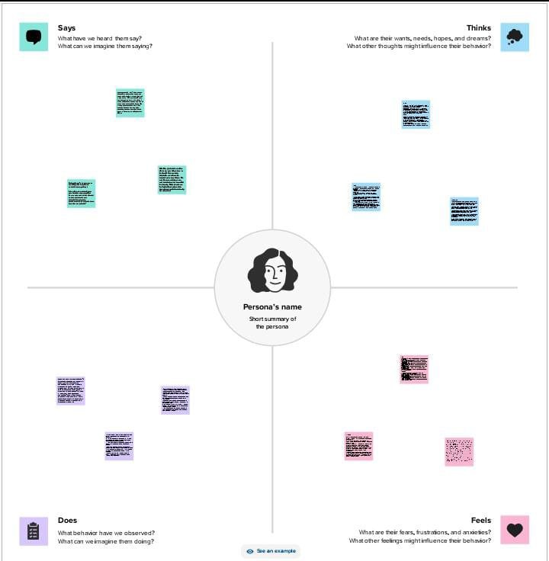

### Ideation Brainstorming Map

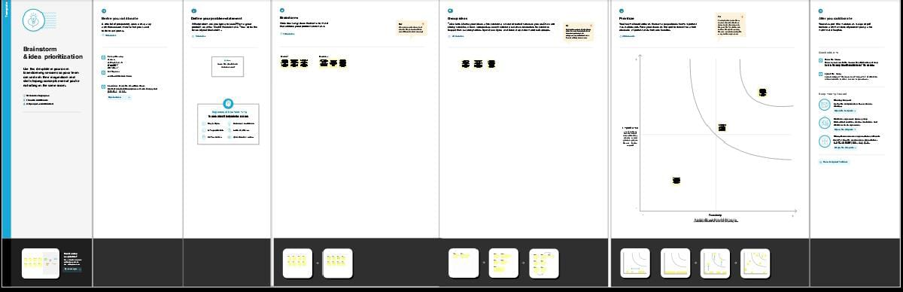

# RESULT:

# You can connect your bank accounts to Zoho Books, which makes it easier to reconcile transactions and track expenses. Set up the products or services your business offers. You'll need these to create invoices and bills. Create and send invoices to your customers. You can customize these with your logo, payment terms, and more. Record your business expenses and bills. You can also connect your bank accounts toautomatically import expenses. Match your bank transactions with your recorded income and expenses to ensure your financial records are accurate. Zoho Books offers various financial reports, such as profit and loss statements, balance sheets, and more. Use these to analyze your business's financial health. Zoho Books can help you manage your taxes. Ensure you set up your tax preferences correctly to simplify tax filing. For information about the integration of HealthHub Medical Clinic with Zoho Books and the results you can expect from this integration, I recommend reaching out to the respective support or customer service teams for HealthHub Medical Clinic and Zoho Books. They should be able to provide you with the most up-to-date and accurate information about the integration and any results you can achieve.

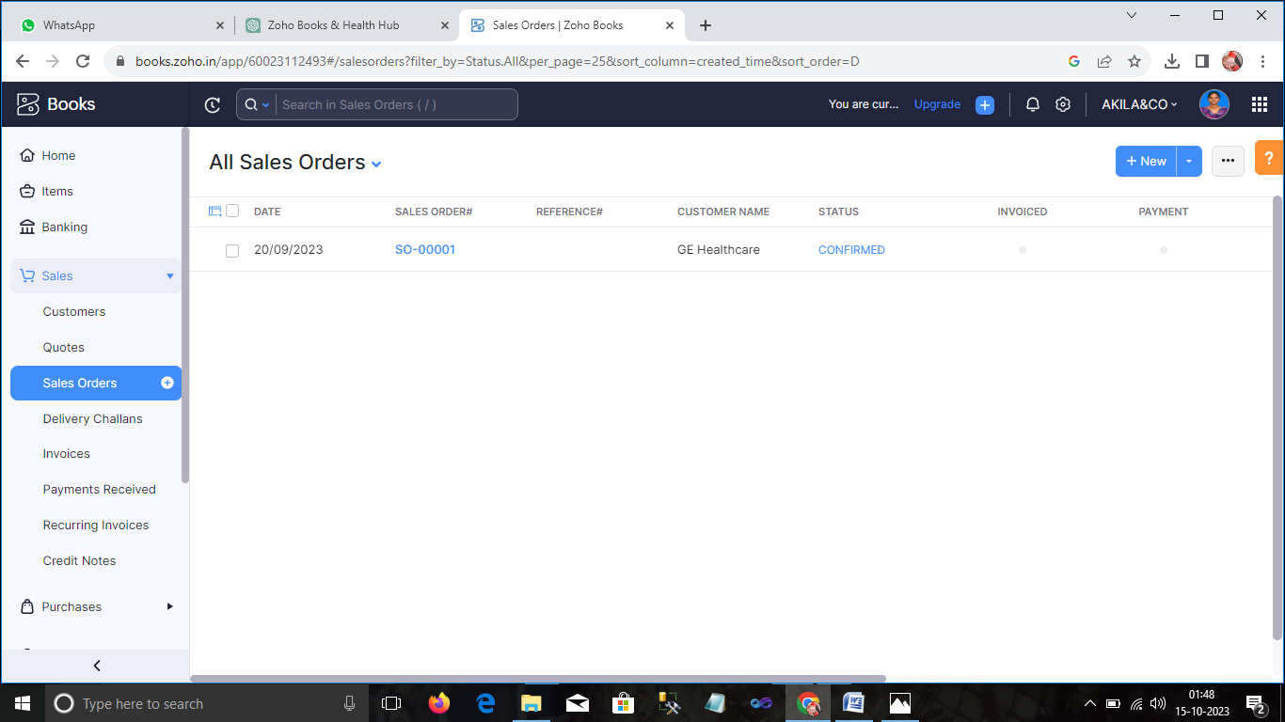

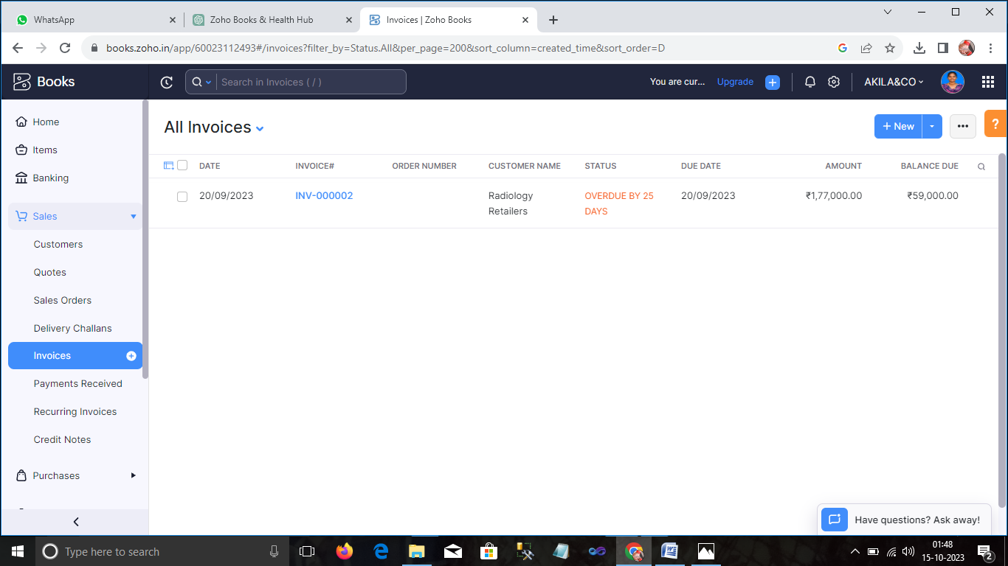

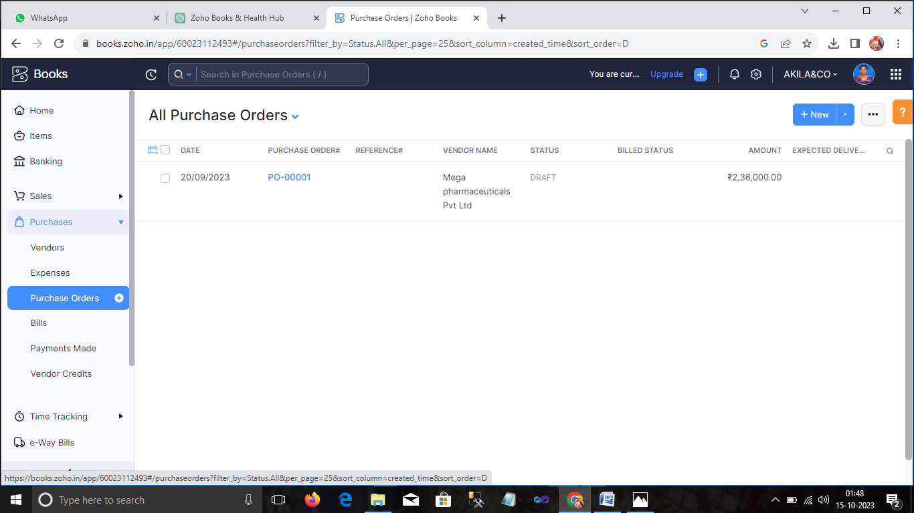

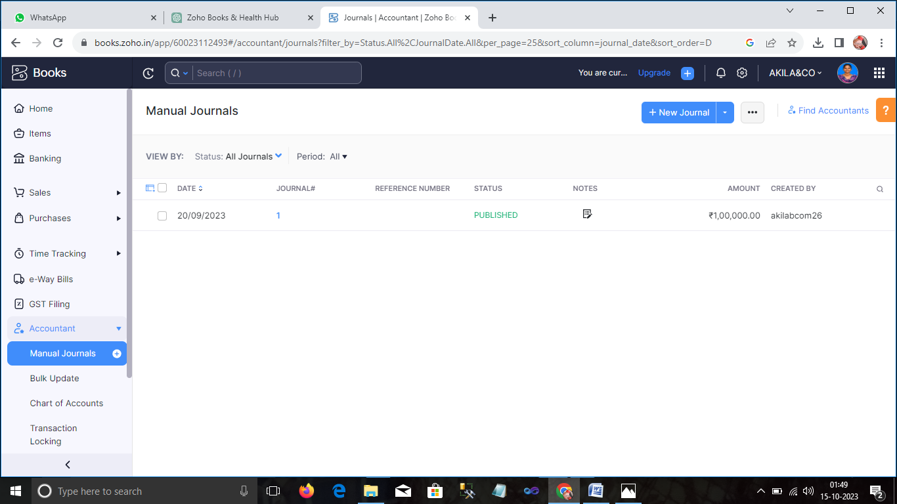

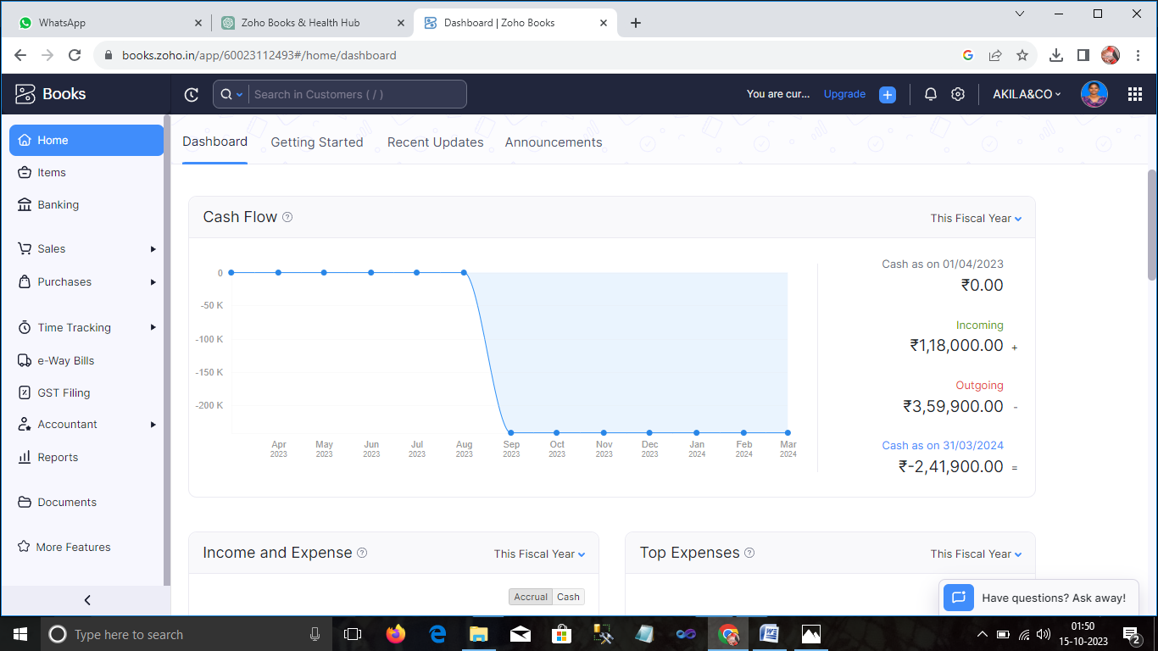

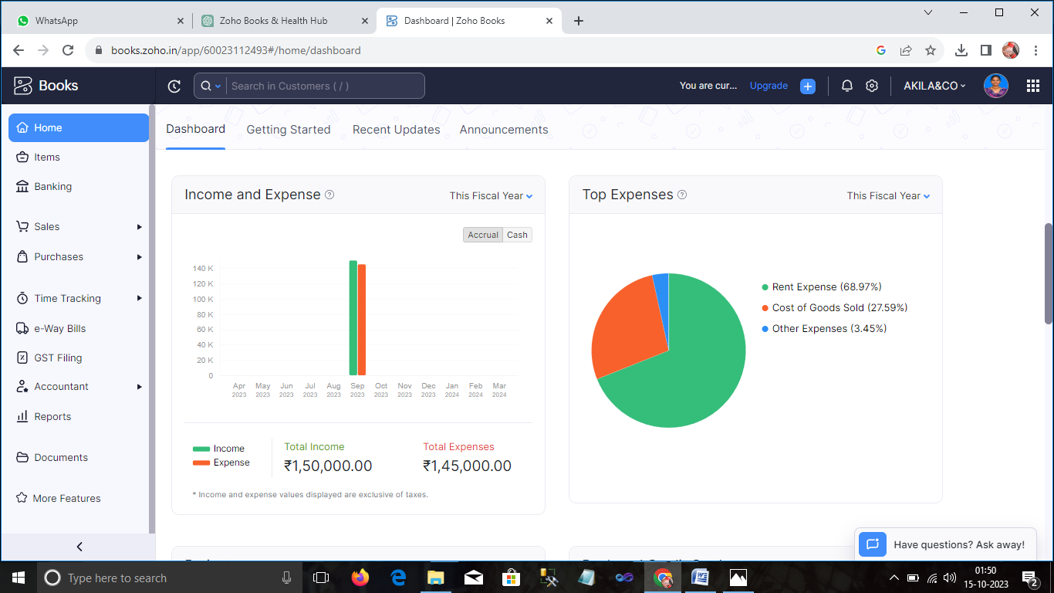

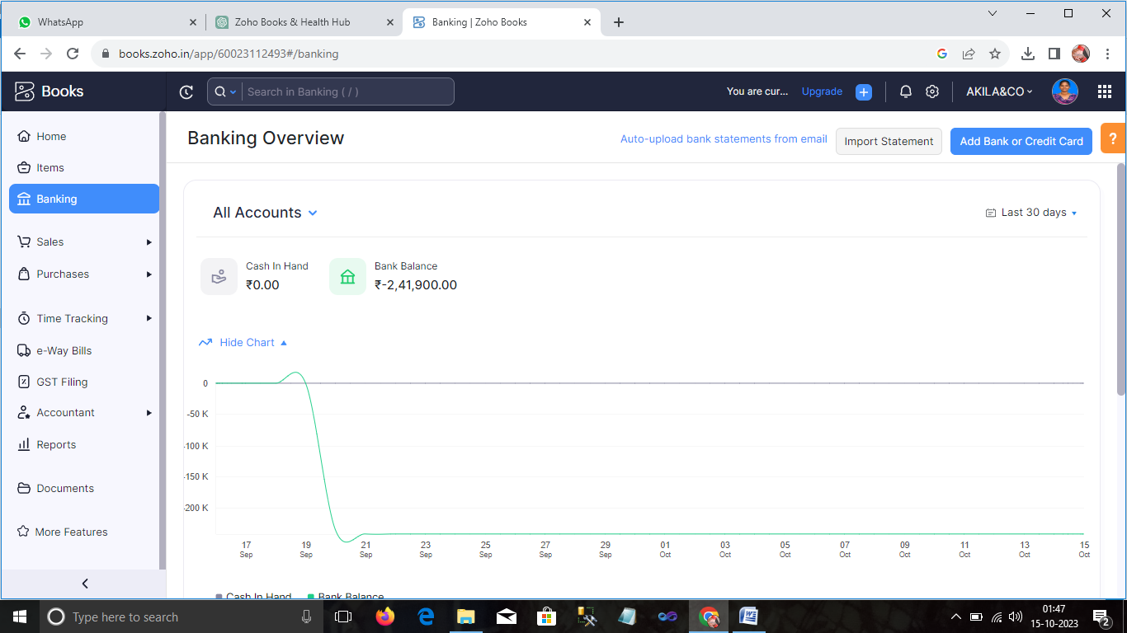

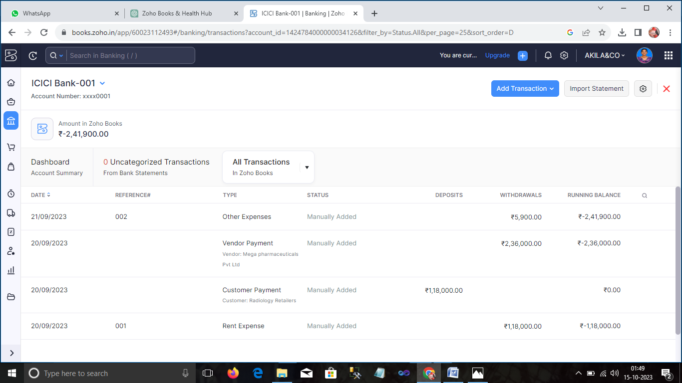

ADVANTAGES:-

* ***Convenient Location:*** A centrally located clinic can be more accessible for patients, making it easier to seek medical care.
* ***Comprehensive Services:*** If Health Hub Medical Clinic offers a wide range of medical services and specialties, it can be a one-stop solution for various healthcare needs.
* ***Experienced Staff:*** Having well-trained and experienced medical professionals can instill confidence in patients regarding the quality of care they will receive.
* ***Reputation:*** A strong reputation for providing high-quality care and excellent patient experiences can be a significant advantage.
* ***Modern Facilities and Equipment:*** Up-to-date technology and facilities can enhance the quality of medical care and diagnostic capabilities.
* ***Appointments and Walk-Ins:*** If the clinic offers flexible scheduling options, including both appointments and walk-ins, it can cater to a broader range of patients' needs.

DISADVANTAGES:-

* ***Wait Times:*** Overcrowded clinics may lead to long wait times, potentially frustrating patients.
* ***Limited Availability:*** Some clinics may have restricted hours or appointment availability, making it challenging to schedule convenient appointments.
* ***High Costs:*** Even with insurance, some medical clinics can be expensive, leading to financial burdens for patients.
* ***Limited Specializations:*** If the clinic doesn't offer a broad range of specialized services, patients with complex medical needs may need to seek care elsewhere.
* ***Quality of Care:*** Not all clinics maintain consistent standards of care, which can lead to variations in quality.
* ***Distance:*** If the clinic is not conveniently located, it may not be practical for some patients to access their services.

APPLICATIONS:-

* ***Electronic Health Records (EHR) Software:*** EHR software is essential for managing patient records, medical histories, diagnoses, treatments, and other patient information electronically. It streamlines administrative tasks and improves patient care coordination.
* ***Practice Management Software:*** Practice management software helps with scheduling appointments, billing, claims processing, and other administrative tasks within a medical clinic.
* ***Telemedicine Software:*** Telemedicine applications enable healthcare providers to offer remote consultations, which have become increasingly important, especially during the COVID-19 pandemic.
* ***Medical Imaging Software:*** Medical imaging applications assist in storing, viewing, and analyzing various types of medical images, such as X-rays, MRIs, and CT scans.
* ***Prescription Management Software:*** These applications help doctors and nurses generate electronic prescriptions and manage medication information for their patients.
* ***Laboratory Information System (LIS):*** LIS software is used to manage and track laboratory test orders, results, and sample data within the clinic.
* ***Mobile Health (mHealth) Apps:*** These applications allow patients to monitor their health, set medication reminders, and communicate with healthcare providers through their smart phones or tablets.
* ***Telehealth Platforms:*** Telehealth platforms facilitate video consultations, secure messaging, and remote monitoring of patients.
* ***Patient Portal:*** A patient portal is an application that allows patients to access their health records, schedule appointments, request prescription refills, and communicate with their healthcare providers online.
* ***Medical Billing and Coding Software:*** These applications help with medical billing, insurance claims, and coding for healthcare services to ensure accurate and timely reimbursement.
* ***Decision Support Tools:*** Decision support software assists healthcare providers in making clinical decisions by offering evidence-based recommendations and relevant medical information.
* ***EMR Integration:*** Applications that enable integration with external Electronic Medical Record (EMR) systems to exchange patient data securely.
* ***Health Information Exchange (HIE):*** HIE software facilitates the secure sharing of patient information between different healthcare providers and organizations.
* ***Patient Management Software:*** This type of software helps manage patient demographics, medical history, and billing information.
* ***Compliance and Regulatory Tools:*** Applications designed to assist healthcare providers in complying with industry regulations and standards, such as HIPAA (Health Insurance Portability and Accountability Act).
* ***Analytics and Reporting Tools:*** Tools that allow medical clinics to analyze patient data, monitor performance, and generate reports to improve healthcare services.
* ***Remote Monitoring Systems:*** These applications help healthcare professionals remotely monitor patients' vital signs and health status, particularly for those with chronic conditions.
* ***Inventory and Supply Chain Management:*** Applications that help clinics manage their medical supply inventory efficiently.

CONCLUSION:-

***Setting Up Zoho Books:***

Ensure you've set up your clinic's information in Zoho Books correctly, including your clinic's name, address, and contact information.

***Chart of Accounts:***

Customize your chart of accounts to reflect the specific financial categories and accounts relevant to a medical clinic, such as revenue, expenses, and liabilities.

***Income and Expenses:***

Regularly record all income and expenses. For a medical clinic, this might include patient payments, insurance claims, payroll, and operating expenses.

***Bank Reconciliation:***

Reconcile your bank and credit card accounts to ensure that your records match your actual financial transactions.

***Invoicing and Billing:***

Create and send invoices to patients or insurance companies as needed. Zoho Books can help automate this process.

***Expense Tracking:***

Record and categorize all expenses, including medical supplies, rent, utilities, and staff salaries.

***Tax Compliance:***

Ensure you are collecting and remitting any applicable taxes correctly.

***Reports and Analysis:***

Use Zoho Books' reporting features to track your clinic's financial performance. This can help in making informed decisions and identifying areas for improvement.

***Integration:***

Consider integrating Zoho Books with other software your clinic uses, such as electronic health records (EHR) systems, for a more streamlined workflow.

***Data Security:***

Ensure that you are following best practices for data security, especially if you are dealing with sensitive patient information.

FUTURE SCOPE:-

* **Telemedicine and Remote Monitoring**: The use of telemedicine is expected to continue growing. Health Hub Medical Clinic can expand its services to include virtual consultations, remote patient monitoring, and telehealth platforms to reach a broader patient base and provide ongoing care.
* **Personalized Medicine**: Tailoring medical treatments to individual patients based on their genetics, lifestyle, and preferences is becoming more common. Health Hub Medical Clinic can invest in personalized medicine approaches, such as pharmacogenomics and precision medicine, to offer more effective and targeted treatments.
* **Chronic Disease Management**: As the population ages, there is an increasing demand for chronic disease management. The clinic can offer specialized programs and services for patients with conditions like diabetes, heart disease, and chronic respiratory illnesses.
* **Wellness and Preventive Care**: Emphasizing preventive care and wellness programs can help patients maintain good health and reduce the burden on the healthcare system. Health Hub Medical Clinic can offer health screenings, lifestyle coaching, and nutritional counseling.
* **Artificial Intelligence and Data Analytics**: Implementing AI for diagnostic support, predictive analytics for disease outbreaks, and electronic health record management can improve patient care and clinic efficiency.
* **Patient Engagement and Experience**: Enhancing patient engagement through mobile apps, patient portals, and improved communication can lead to better outcomes and higher patient satisfaction.
* **Integration of Alternative Therapies**: Integrating complementary and alternative medicine (CAM) services, such as acupuncture, chiropractic care, and herbal medicine, can expand the range of services offered.
* **Genomic Medicine**: The use of genomics in healthcare is growing. Health Hub Medical Clinic can explore genetic testing and counseling services to provide patients with insights into their genetic predispositions.
* **Mental Health Services**: Expanding mental health services to address the growing demand for counseling, therapy, and psychiatric care is crucial, especially in a post-pandemic world.
* **Collaboration with Specialists and Hospitals**: Building partnerships with specialists and hospitals for referrals and collaborative care can provide comprehensive services to patients.
* **Remote and Wearable Technologies**: Embracing remote monitoring devices and wearable technology can facilitate better tracking of patients' health and improve the clinic's ability to provide timely interventions.
* **Regulatory Compliance**: Staying up-to-date with healthcare regulations, including data security (HIPAA compliance) and insurance requirements, is crucial to ensure smooth clinic operations.
* **Community Outreach and Education**: Hosting health education programs and community outreach events can help raise awareness and establish the clinic as a trusted resource in the community.
* **Global Expansion**: If applicable, consider expanding services beyond local or national borders, tapping into international patient markets or establishing satellite clinics in regions with healthcare needs.
* **Sustainability and Green Healthcare**: Adopting sustainable practices and eco-friendly technologies can contribute to a clinic's reputation and help address environmental concerns.

**APPENDIX**

Source code: **NM2023TMID25289**

Attach the code for solution built.